**Patti Gallagher’s 2008 Irish Vacation**

In June of 2008, I treated myself to a “Wayfarers Walking Vacation” in Ireland. I had longed to return to Ireland since 1976, when I attended a two week summer course on Irish literature at Galway University, and afterwards traveled all over the country for three weeks. I met distant relatives, visited the stone, thatched cottage where my Grandmother, Rose Ann Wynne, was born and the cemetery where my grandmother’s relatives were buried. I had wanted to return to Ireland for years, but LIFE got in my way and I did not have another opportunity until 2008.

The Wayfarers Walk was titled “The Ring of Kerry – Celtic Pride and Irish Hospitality.” The Wayfarers have been leading walking vacations all over the world since 1984 and they do an amazing job. Since 2008, I have been on three more Wayfarers walks in England.

This walk was five days, six nights which began and ended in the city of Killarney. Our group of seven stayed at beautiful hotels and inns where we were served breakfast before walking 7-12 miles each day. Two hours into our walk the Wayfarers van would meet us, provide drinks and snacks and give us a menu for the pub or restaurant where we would be stopping for lunch. We would select our meal, which would be ready and waiting for us when we arrived.

After lunch we would walk to the destination where we would have a delicious dinner and spend the night. The van took our luggage from one hotel/inn to another whenever we changed locations for the night. So, basically all our group, led by our fearless, funny, entertaining and very patient walk leader, Alan Pinkney, had do was eat, walk, eat, walk, freshen up and rest before dinner, have dinner, followed by entertainment, (traditional Irish music, story-telling, Irish dancing), or just hanging out in a local pub, get a good night’s sleep and start all over again in the morning!!

We walked over beautiful heather-covered or emerald rolling hills, on ancient drovers’ trails, into primeval forests, on wild beaches and beside gorgeous lakes and waterfalls. Throughout each day, Alan entertained and educated us with lessons in Celtic history, culture, geography, flora and fauna, Irish literature, politics and folklore.

One day we walked for hours in what truly felt like a magical, mystical forest. Alan, who kept running ahead of the group and disappearing into the woods, had said at the beginning of the walk “if we don’t see a leprechaun today, we probably never will.” Eventually we came upon a very ancient tree whose roots were exposed and hanging down the side of a hill. Alan was standing inside the tree’s roots and when I looked up I saw a leprechaun above him! Since I was the one who discovered the leprechaun, I got to keep him as a prize! That little fellow, whom I named “Shenanigan MacGillycuddy” (after “MacGillycuddy Reeks,” a mountain range above Kenmare, Ireland) became my good luck charm and has been my traveling companion ever since! I never get on an airplane or take a road trip without Shenanigan.

 In 2019, I became an Irish Citizen, so I now have dual citizenship!

Erin go bragh!

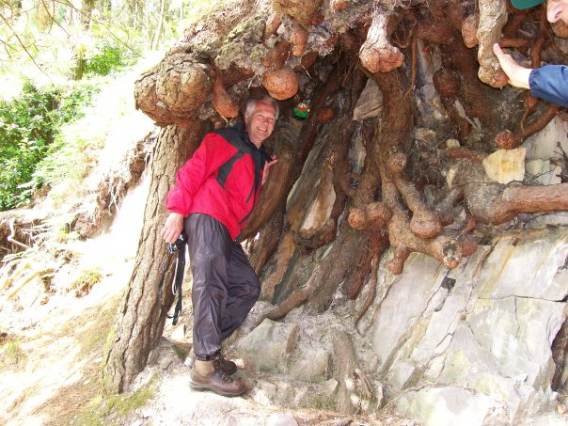 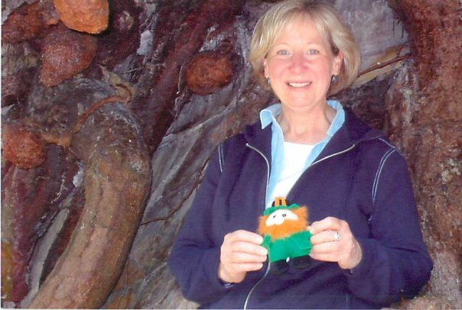

Alan Pinkney in the tree with the Leprechaun Shenanigan MacGillycuddy and me

1976 Towneycorry, Carrick on Shannon, County Leitrim, Ireland

With my friend, Eileen Folan, in front of my Grandmother, Rose Ann Wynne’s (Guhien, Irish spelling) thatched, stone cottage.

Guhien (Wynne) Family Tombstone